**Saint Brigid Saint John the Baptist**

11th Sunday in

Ordinary Time

June 17, 2018

**Catholic Church Catholic Church**

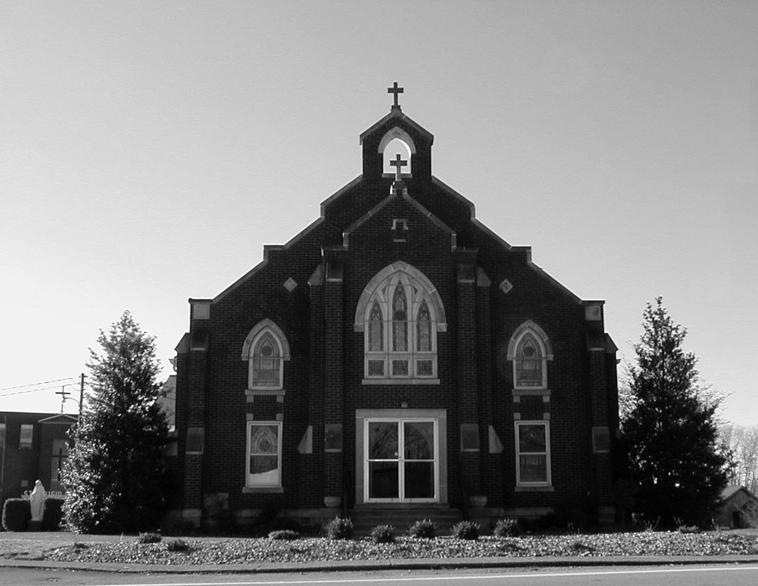

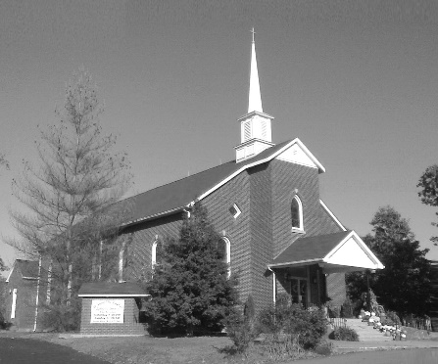

**Pastor:**

***Rev. Daniel L. Lincoln***

Rectory: (270) 877-2546

**Deacon:**

***Michael A. Ryan***

(270) 272-6789

314 E. Main St. 657 St. John Church Rd.

Vine Grove, KY 40175 Elizabethtown, KY 42701

Clustered Parish Office: Clustered Parish Office:

(270) 877-2461 (270) 877-2461

**ANNOINTING OF THE SICK:**

Notify the parish office when a family member is hospitalized.

**BAPTISM:**

Contact the parish office for information about the required preparation class.

**BULLETIN:**

Information must be submitted in writing by note or email to the parish office **no later than 12:00 noon on Wednesdays** for the following weekend. When sending an email, please put “BULLETIN,” and the name of the parish the announcement is for, in the subject line.

**MARRIAGE:**

Contact Father at least 6 months prior to the wedding date to complete required marriage preparations and to schedule the date.

**RCIA (Rite of Christian Initiation of Adults):**

Contact the Worship Chairperson for information.

**DEW MEMORIAL LIBRARY:**

(in St. Brigid Church basement):

Open: Sunday after 9:30 a.m. Mass& 45 minutes before all other Masses.

Email: [brigidvg@bbtel.com](mailto:brigidvg@bbtel.com)

Website:[www.stbrigidvg.org](http://www.stbrigidvg.org)

**Pastoral Associate & Dir. Dir. of Religious Education:**

**of Religious Education:** Lisa Thomas: (270) 735-6930

Deacon Mike Ryan: (270) 877-0546

**Youth Minister: Youth Ministers:**

Lori Law: (270) 723-0157 Angela Churchman:

(270) 268-9963

Ericka Finlay: (502) 612-2644

**MASS SCHEDULE:**

*Sunday:* 9:30 a.m. & 6:30 p.m.

*Monday:* 9:00 a.m.

*Thursday:* 9:00 a.m.

**RECONCILIATION:**

Sunday before Mass

5:30-6:00 p.m. or by appt.

**ROSARY:**

After weekday Masses

**PARISH COUNCIL MEMBERS:**

*President:* Sue Weisshaupt

*Vice-President:* Mike Bramlett

*Secretary:* Judy Cochran

*At-Large Members:* Blake Ryan

& Vincent Thompson

**CHAIRPERSONS:**

*Administration:* Dale Winchester

*Formation:* Tina Yates

*Parish Life:* Tom Billings

*Worship:* Keith Baughman

**MASS SCHEDULE:**

*Saturday (Vigil):*  6:30 p.m.

*Sunday:* 11:30 a.m.

*Wednesday:* 6:30 p.m.

*Friday:* 9:00 a.m.

**RECONCILIATION:**

Saturday before Mass

5:30-6:00p.m. or by appt.

**PARISH COUNCIL MEMBERS:**

*President:* Theresa Smith

*Secretary:* Karen Ray

**CHAIRPERSONS:**

*Administration:* Rick Newton

*Formation:* Ericka Newton

*Parish Life:* Bradley Wickersham

*Worship:* Nick Thomas



**Mass Schedule**

**Mass Schedule**

|  |  |  |  |  |  |
| --- | --- | --- | --- | --- | --- |
| **Saturday** | **June 16** | **6:30 p.m.** | **St. John** | **For All Parishioners** | **Vigil: 11th Sunday in Ordinary Time** |
| **Sunday** | **June 17** | **9:30 a.m.** | **St. Brigid** | **Mack, Leanna & Billy Cecil** | **11th Sunday in Ordinary Time** |
| **“** | **“** | **11:30 a.m.** | **St. John** | **Bruce Sherrard** | **“** |
| **“** | **“** | **6:30 p.m.** | **St. Brigid** | **Our Parish Family**  **Dickie Cecil** | **“** |
| **Monday** | **June 18** | **9:00 a.m.** | **St. Brigid** | **Smith Family**  **Helen C. “Dinky” Adams** | **Weekday** |
| **Wednesday** | **June 20** | **6:30 p.m.** | **St. John** | **For Special Intentions** | **Weekday** |
| **Thursday** | **June 21** | **9:00 a.m.** | **St. Brigid** | **Carlos Robbins**  **Dickie Cecil** | **St. Aloysius Gonzaga, Religious** |
| **Friday** | **June 22** | **9:00 a.m.** | **St. John** | **In Thanksgiving** | **Weekday** |
| **Saturday** | **June 23** | **6:30 p.m.** | **St. John** | **Living & Deceased Emil & Anna**  **Brangers Family Members** | **Vigil: The Nativity of**  **St. John the Baptist** |
| **Sunday** | **June 24** | **9:30 a.m.** | **St. Brigid** | **Our Parish Family**  **Louise Stith** | **The Nativity of St. John the Baptist** |
| **“** | **“** | **11:30 a.m.** | **St. John** | **For All Parishioners** | **“** |
| **“** | **“** | **6:30 p.m.** | **St. Brigid** | **Sandi Crutcher** | **“** |

**INFORMATION FOR BOTH PARISHES**

**HAPPY FATHER’S DAY** – May God bless all our fathers with joy, happiness and peace.

**KEEPING HIGH SCHOOL GRADUATES IN TOUCH WITH THEIR FAITH** – As some of our youth go away to college for the first time this fall, you can submit the student’s name and college to the *Newman Connection* online. This will enable the college’s local Catholic community to contact the student about Catholic social functions as well as the time and location of weekend Masses. If interested, you can do this at [www.serraus.org/serrausa/serra_connect.htm](http://www.serraus.org/serrausa/serra_connect.htm) or you can contact Chuck Lynch of the Serra Club of Louisville, at (502) 442-9302 or [ChuckLynch4782@gamil.com/](mailto:ChuckLynch4782@gamil.com/)

**HOSPARUS HEALTH** – needs volunteers to visit with patients and provide respite for their families/caregivers. A training and screening process is required. You may apply online at HosparusHealth.org or contact Annette Jones at the Elizabethtown office for more information at (270) 737-6300 or [ajones@hosparushealth.org](mailto:ajones@hosparushealth.org).

**ABORTION AND ADOPTION –** The number of would-be adoptive parents (of newborn babies) far outstrips the supply in America. Each year in the United States, about 135,000 American children are placed for adoption. Experts estimate somewhere between one and two million couples seek to adopt yearly. Every year, there are about 1.3 million abortions. Sadly, only 4% of women with unwanted pregnancies give their children up for adoption. Every child is wanted and wanted desperately! By Pro-Life Articles Author [www.pro-lifearticles.org](http://www.pro-lifearticles.org)

**PROJECT RACHEL** **–** Healing…Forgiveness…Hope…After the experience of an abortion. If you or someone you know is struggling with the pain from an abortion, please consider Project Rachel – a post abortion ministry. To speak to someone confidentially, call (502) 471-2155 or email [ProjectRachel@archlou.org](mailto:ProjectRachel@archlou.org).

**CONFIDENTIAL PREGNANCY AND ADOPTION COUNSELING** – is available at Catholic Charities for women of all ages experiencing untimely pregnancies. A full range of services are provided, including adoptive placement, legal assistance and counseling for individuals, groups and families. Post-abortion counseling is also available. Services are provided regardless of income or marital status. For more information, call Catholic Charities at (502) 637-9786.

**SAVE THE DATE** – Fr. John Judie will have a celebration of his retirement, 70th birthday and 31 years of priestly ministry on **Saturday, August 11, 2018**. More details will follow later. He may be reached at (502) 774-5772.

**Rite of Christian Initiation for Adults (RCIA) – Summer Session**

Date: **Tuesday, June 19, 2018, 7:00 p.m.** Topics: Mass [Q3]

Place: CMR (Church Meeting Room in Prayer [Q10]

basement of the church

Facilitator: RCIA staff

Anyone interested should contact Keith Baughman at (270) 877-5283 or the Parish Office at (270) 877-2461.

Leave your name and phone number.

**St. John and St. Brigid Prayer List**

To add someone to the prayer list, please call the parish office at (270) 877-2461. **Remember to call to remove someone from the list if they are no longer sick, etc.** *Please note that the prayer list has been revised. It is primarily for parishioners and their immediate family members*.

Leslie **Adams-Cerniglia**, Sam **Adams**, April **Allen**, Dennis **Arnold**, Barbara **Ashley**, Donnie Alan **Atcher**, Sue **Banks**, Shannon **Barnes,** Denise **Barnett**, Timothy **Birch**, Teresa **Laycock**, Charlie **Bowers**, Pauline **Brangers**, Ellen **Bryan**, Richard **Bryson**, Carol **Buchanan**, Jeremy & Margie **Buyer**, Deacon Bob **Caspar**, Sue **Caswell**, Ed **Cecil**, J. Mack **Cecil**, Harlan Ford **Clark**, Judy **Cleaver**, John **Connor**, Betty Jo **Cooper**, Heidi **Correa**, Jeff **Craig**, Glynn **Clutches**, Roan **Dowell**, Karen **Dworshak**, Leroy **Embry**, Marion **French**, Martha **Ford**, Dwayne **Garcia**, Carrie **Gribben**, Mary **Hager**, Mrs. Charles **Hair**, Stephanie **Hall**, Donnie **Hart**, Jimmy **Harper**, Bobby **Harris**, Eileen **Heinen**, Debbie **Hodge**, Betty Lou **Jones**, Andrew **Kieta**, Charlene **Langley**, Olivia **Leasor**, Jenny **Leonhardt**, Jackie **Long**, Louise **Lucous**, Alma **Mahanna**, Shelly **Martin**, Shirley **Martin**, Martina **Masoni**, Don **Mattingly**, Gerard **Mattingly**, Paul Michael **Mattingly**, Mary **Medley,** Cindy **Miller**, Starla **Miller**, Doug **Osborne**, Duane **Osborne**, Fr. Stan **Osborne**, Mickey **Padgett**, Frank **Inanely**, Polly **Prather**, Annie **Pierce**, Adrianna **Porter**, Jeremy **Porter**, Adrian **Ray**, Allie **Ray**, Mary Agnes **Ray**, Mary Ellen **Ray**, Tonya **Reisinger**, Joel **Rivera**, Caroline **Seabee**, Darlene **Staples**, Ralph **Staples**, Joan **Stith**, Keith **Tassin**, Kenny **Thompson**, Raffaella **Tucker**, Debi **Turner**, Stacey **Vance**, Charlotte **Vowels**, Bill **Waldrop**, Lois **Weaver**, Paul A. **Whelan**, Jennifer **Williams**, Sandy **Wiseman**, Zach **Wiseman**, Gail **Wilson**, Don **Wooldridge**, Connor **Wright**, Rose Marie **Yates** and all the sick.

* * * * * * * * * * * * * * * * * * *

**Our Military List**

To add someone to the military list, please call the parish office at (270) 877-2461. **Remember to call to remove someone from the list if they are no longer in the service**.

Lt. Matt **Bednar**, PFC Richard H. **Chapman**, A1C Aaron **Chandler**, A1C Brandon **Davila**, SrA Felicia **Esquivel**, PFC Tyler **Hall**, A1C Ryan **Henley**, A1C Joseph **Manco**, SPC Jacob L. **Nall**, SFC Peter **Novak**, Tony **Rickerl**, Lt. Col. Paul **Rigby**, 0James **Rogers**, Tony **Rogers**, Jonathon **Sifford**, Jeffrey **Slade**, Derek **Smith**, CSM Vance **Snider**, Brian **Tomassi**, A1C Daniel **Trombone**, SGT Evan **Vaughan**, PV2 William **Vaughan**, Lisa **Flynn-Veri**, LT Michael **Veri**, LTC Steve **Wickersham**, SGT Clay **Wilson**, TSGT Jeremy **Yates**, Austin **Zulka** and for all who serve and have served our country.

* * * * * * * * * * * * * * * * * * *

**ST. JOHN THE BAPTIST CATHOLIC CHURCH INFORMATION**

**Monthly Budget Amount Needed:** $ 12,500.00

**Monthly Collection for May:** $ 10,455.70

**Monthly Collection for June:**  $ 4,671.00

**WELCOME PACKETS** – If you would like to become a member, or learn more about St. John Parish, please take a *Welcome Packet* in the church lobby. You may return the census card and the stewardship form to Father Dan or place in the collection basket.

**STEWARDSHIP UPDATE –** We are wrapping up our stewardship drive this weekend.  If you have not completed your form, it is not too late. Forms will be in the back of church the next few weeks. We will also be mailing a copy to anyone that we think has been missed.  The goal of the Discernment Committee is to have all this information compiled and over the next several months start scheduling meetings with the committees to formulate plans for each of these ministries.  Many of you have expressed interest in some new ministries and activities.  The goal of the Discernment Committee is to help get the ball rolling on these ideas.  Let’s keep the ball rolling by actively engaging in these meetings as they are scheduled and by prayerfully considering what gifts we have to offer as we move forward with these plans.   Also, the list for Mass duties will be updated and new copies distributed.  Should you have any questions for the Discernment Committee regarding these plans you may contact:  Clarissa Yates, Erica Finley, Karen Ray, Rick & Rhonda Newton, or Lisa Thomas.

**PARISH COUNCIL ELECTIONS** – Take a ballot and vote for one man and one woman. Thanks to Mike Meredith, Greg Thompson, Lauran Thomas and Linda Thomas for running. Voting ends today.

**PARISH COUNCIL** – will meet on **Monday, June 18, at 6:30 p.m.** in the Parish Hall.

**VACATION BIBLE SCHOOL MEETING** – An organizational meeting will be held on **Wednesday, June 20, at 7:00 p.m.** in the Parish Hall. We always need lots of help for this week of fun and education.  Youth must be 7th grade and up. If you have any questions, please contact Clarissa Yates @ (270) 862-3792 or [cpyates@comcast.net](mailto:cpyates@comcast.net).

**SAVE THE DATE – VACATION BIBLE SCHOOL** – will be **Sunday-Thursday, July 15-19, from 6:00-8:30 p.m.** Make plans now for a great week! If you have any questions, contact Clarissa Yates, [cpyates@comcast.net](mailto:cpyates@comcast.net) or (270) 862-3792.

**FR. STAN OSBORNE** – can be reached at Nazareth Home, Room 112, 2000 Newburg Rd., Louisville, KY 40205.

* * * * * * * * * * * * * * * * * * *

**St. John Liturgical Ministers**

|  |  |
| --- | --- |
| **Vigil: The Nativity of St. John the Baptist, June 23, 2018** | **6:30 p.m.** |
| Extraordinary Ministers of the Eucharist | Becky Thomas Dennis Thomas Marcella Crewz |
| Lector | Joanna Sherrard |
| Servers | Volunteers |
| Greeter(s) | Joanna Sherrard |
| Gift Bearers | Fred & Carmel Pike |
| - Ushers | Charlie French Jackie Hall |
| **The Nativity of St. John the Baptist, June 24, 2018** | **11:30 a.m.** |
| Extraordinary Ministers of the Eucharist | Martha Thomas Libby Brangers Scott Mattingly |
| Lector | Lucy Ramos |
| Servers | Felicity Ramos Mya Reddick |
| Greeter(s) | Clarissa Yates |
| Gift Bearers | Aimee Hunt & Family |
| Ushers | Brandon Wiseman David Yates |
| **Hospital Ministry – Sunday, June 25, 2018** | Marcella Brangers |

**ST. BRIGID CATHOLIC CHURCH NFORMATION**

**Monthly Budget Amount Needed:** $ 25,280.00

**Monthly Collection for May:** $ 22,991.57

**Monthly Collection for June:** $ 11,504.00

**WELCOME VISITORS** – If you are interested in joining our parish, please pick up a Welcome Packet at the church doors. Complete the registration form and either drop it in the collection basket or mail it to the office. If you just need to update your registration, there are also forms available.

**HAPPY BIRTHDAY** – Frances Singer will be celebrating her 100th Birthday on **Monday, June 25.** She is Agnes Yates’ aunt. She has been residing at Signature HC at North Hardin for the last 11 years. Agnes would like to ask our parish family to send her a birthday card. Her address is Frances Singer – Rm. 408, 599 Rogersville Rd., Radcliff, KY 40160.

**CONGRATULATIONS** – Ralph and Sherleen Barren celebrated their 50th wedding anniversary on June 15.

They were married by Rev. Howard French as his first  
official act as pastor of our parish in 1968.

**PARISH COUNIL ELECTIONS** – Nominations for three positions on the Parish Council will be taken for the weekends of **June 10 & 17**. Nominees must be 18 years and older and a registered member of St. Brigid Parish. You must have the person’s consent before they can be nominated. Forms are at the doors.

**CHURCH CHOIR** – We could use more choir members, most especially altos and tenors. Ladies, if you can’t sing high notes you are an alto. You do not have to sing every Sunday Mass though you are more than welcome to. Please consider this gift to your church.

**BASKETBALL?** I have heard that there may be interest in a basketball program for children, teens and possibly adults. We would need the following: someone to run the program, coaches, referees, scoreboard keepers, and concessions. But most of all we need the people interested in doing this to come forward. We have the facility and the know-how, why not use it. If interested, please contact Deacon Mike Ryan. There will be sign-up sheets at the church doors for whatever you may want to do or help with. Call Deacon Mike at (270) 877-0546.

**RELIGIOUS EDUCATION TEACHERS –** There will be no religious education meeting on June 10, 2018. There will be a meeting announced later in July for religious education.

**RELIGIOUS EDUCATION** – We should have more students than 35 in pre – 8 and more than 14 in 9 – 12. Religious education is the parents’ responsibly. Your child is our church’s future. If you leave it up to the child, he or she won’t go. This is where the parent needs to be in control. Religious education is free at Saint Brigid. Your child is important - our program is important. Please register your child today. Forms are at the doors of the church. If you have questions, please contact pastoral associate Mike Ryan at (270) 877-0546 or [mryan@bbtel.com](mailto:mryan@bbtel.com).

**MOVIE NIGHT** – I have been looking at doing a movie night once a month on Friday night. I’m looking at Christian based movies and good children’s movies. I would like to know if anyone is interested in this ministry. Please contact pastoral associate Mike Ryan at (270) 877-0546 or [mryan@bbtel.com](mailto:mryan@bbtel.com).

**SUMMER EVENT TICKETS** – are on sale at the back of church on Sundays and at the office.

**SUMMER EVENT** – The Summer Event will be **Sunday, September 16**. That way we are not competing with St. Martin’s picnic or the Vine Grove Autumn festival. The lunch is from 1:00-3:00 p.m. The silent auction ends at 3:45 p.m. The main drawing will be at 4:00 p.m. Diane Taylor will cater the meal.  She can do a BBQ pork sandwich, baked beans, either claw slaw or potato salad, sweet and unsweet tea and, water.  She will also do a hot dog for children (or adults that don't want BBQ). We will have the food served in the new cafeteria.  We would still need teens to help serve drinks and bus tables and clean up like we do at the KC Hall now. The Summer Event Ticket Order Forms are at the side doors of the church and the table in the back of church. Should anyone need additional information please contact Teresa Morgan (270) 862-2909; Gina Ryan (270) 735-6355 or Deacon Mike Ryan (270) 877-0546 or (270) 272-6789.

**COMMUNION MINISTER UPDATE SESSIONS** – are for those ministers needing a mandate renewal, who have already completed the archdiocesan two-session Communion Minister Formation Program. This session will fulfill the requirements for continuing formation for Extraordinary Ministers of Holy Communion. I have scheduled the mandatory update session for **September 27, 2018 from 7:00- 9:00 p.m.** Please add to your calendar. I will put the form applications out three weeks before and make sure a new announcement gets into the bulletin. Should you have questions please contact Deacon Mike.

* * * * * * * * * * * * * * * * * * *

**St. Brigid Youth Ministry**

**Wednesday, June 20** **– Holiday World!** Our yearly trip to Holiday World is open to all high school youth. To help with the buddy system, everyone is welcome to invite **1** friend if they want. Permission forms and details were mailed as part of the summer packet, if you did not receive a summer packet, there are extras in the back of the church. A verbal RSVP is due by Monday so I can arrange enough drivers and purchase tickets. Your fee and permission slips are due the morning we leave. A rain date will be picked if weather is bad.

**Wednesday, June 25** – Open Swim at Lori’s for all youth entering the 8th grade through 12th. The evening runs from 5:00-9:00 p.m. with swimming, food, relaxing by the pool, playing corn hole and much more. If you need my address or directions, please call or text the number below.

**Christian Leadership Retreat** – will run from **July 9-13** and is for anyone who has completed their sophomore or junior year of high school. Please contact Lori for more details and permission forms if you are interested. The sooner you apply the better chance of getting a spot and the cheaper it is.

If you have any questions, please contact Lori at (270) 723-0157 or email at [stbrigidyouth@hotmail.com](mailto:stbrigidyouth@hotmail.com).

* * * * * * * * * * * * * * * * * * *

**Formation News**

Please pick up a "Little Burgundy Book" at the church doors. This booklet follows the same format as the Advent and Lent season booklets, but it is themed for stewardship. It is 4 weeks long and undated so this booklet can be used at any time of the year for personal reflection.



**St. Brigid Liturgical Ministers**

|  |  |
| --- | --- |
| **The Nativity of St. John the Baptist, June 24, 2018** | **9:30 a.m.** |
| Extraordinary Ministers of the Eucharist P. | Angie Bragg Alison Dupont |
| C. | Nancy Kotarski Mark Kelly Paula Greenwell Rose Cooper |
| Lector | Karen Harris |
| Servers | Gabe Russell Maggie Board |
| Greeters | Keith & Martha Baughman Chad Sims |
| **The Nativity of St. John the Baptist, June 24, 2018** | **6:30 p.m.** |
| Extraordinary Ministers of the Eucharist P. | Ron Masoni |
| C. | Donna & Richard Osterhage |
| Lector | Ashley Osterhage |
| Servers | Nathaniel Morgan Christopher Morgan |
| Greeters | Volunteers |
| **Hospital Ministry – Sunday, July 9, 2018** | Keith Baughman Jim Klimesh |

**St. Brigid Monthly Meet and Greet**

St. Brigid Parish hosts a “Meet and Greet” downstairs the 2nd Sunday of each month immediately following the 9:30 a.m. Mass with coffee and donuts. This is a great opportunity for existing parishioners to extend a warm welcome to visitors and anyone interested in joining St. Brigid Parish. Be sure to also visit the Dew Memorial Library. **The next Meet and Greet will be Sunday, July 8, 2018.**

*Marriage Moments* –

Summer officially begins June 21. Traditionally this is a time of rest and vacations. Have you planned a get-away for just the two of you? Even if you can’t take a “real” vacation, fantasize together about a dream vacation either at home or away. A staycation counts. Visit <https://www.livingwellspendingless.com/2014/03/07/staycation-ideas/>.

*Parenting Points –*

“Our Father, who art in heaven…” Note that we say “Our” Father not “My” Father since God is father to all the children of the earth. Yes, remember your own father on June 17, but also remember those children whose father is absent, unemployed, deployed to a foreign land, abusive, or in some other way not present. Can you be like a father to someone who needs you?